# CS 255 System Design Document Template

*Kayleigh Kinsey*

*2/17/23*

## UML Diagrams

### UML Use Case Diagram

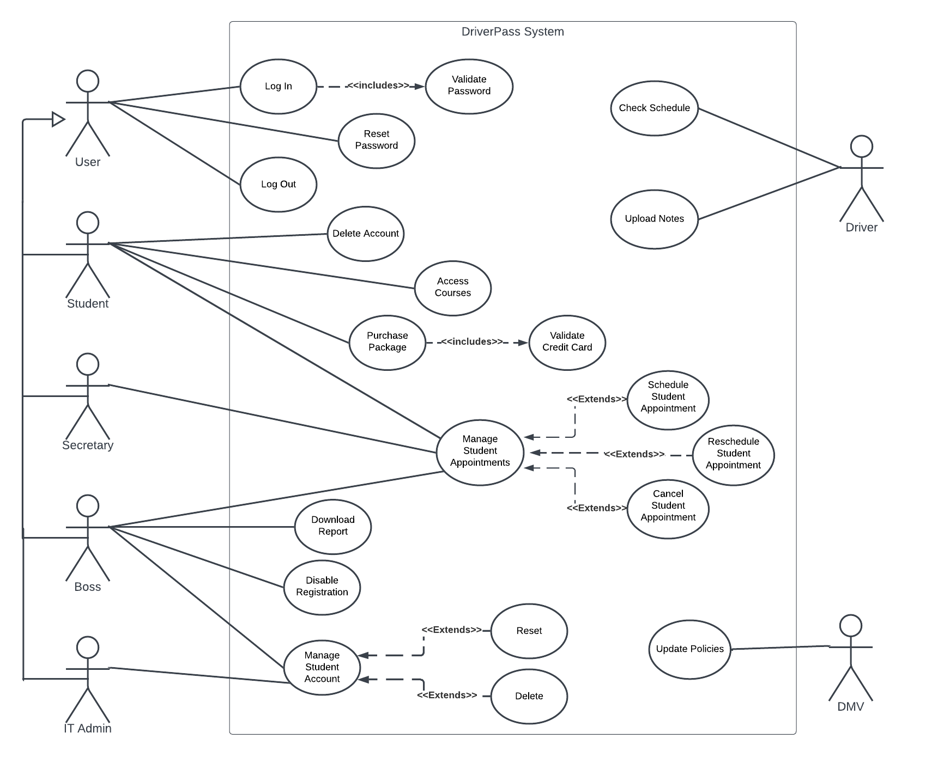

### UML Activity Diagrams

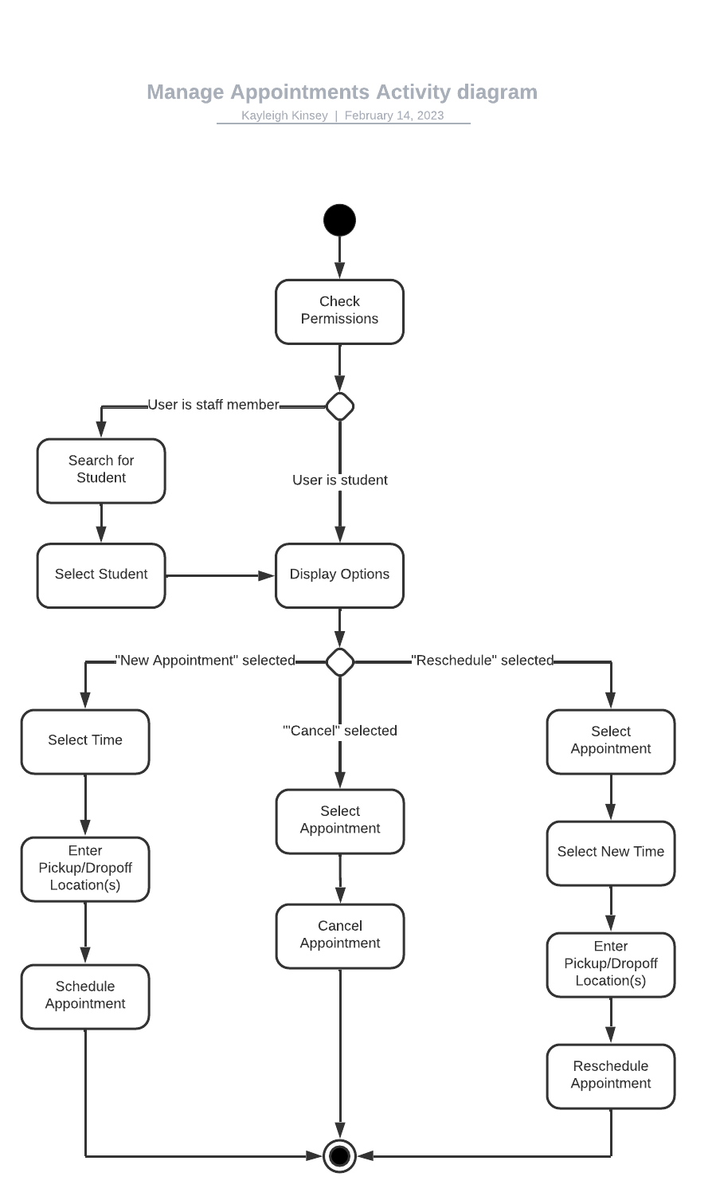

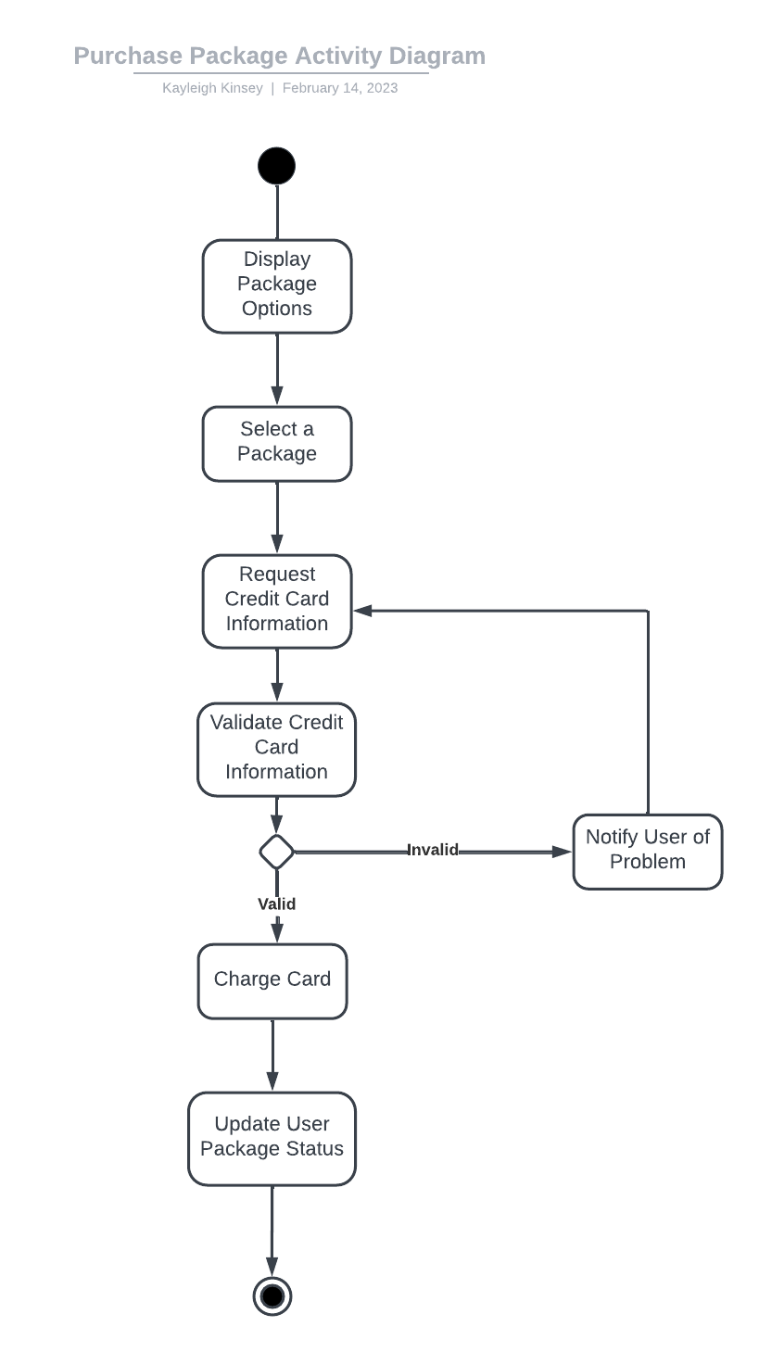

### UML Sequence Diagram

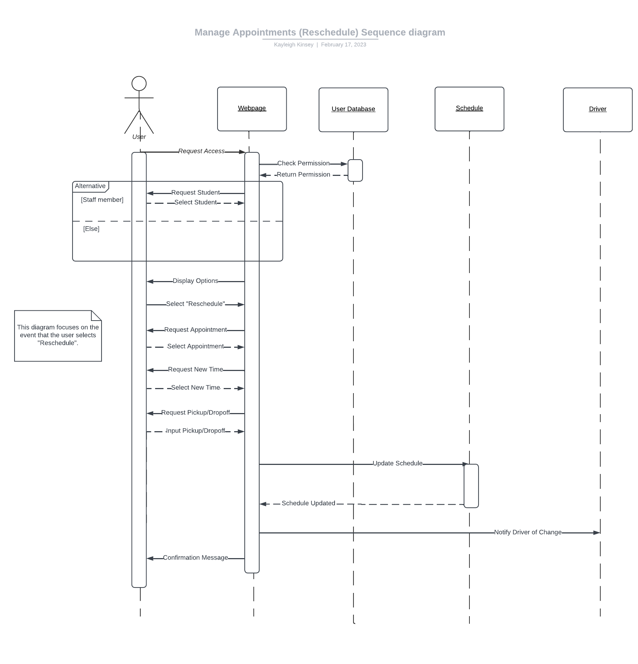

### UML Class Diagram

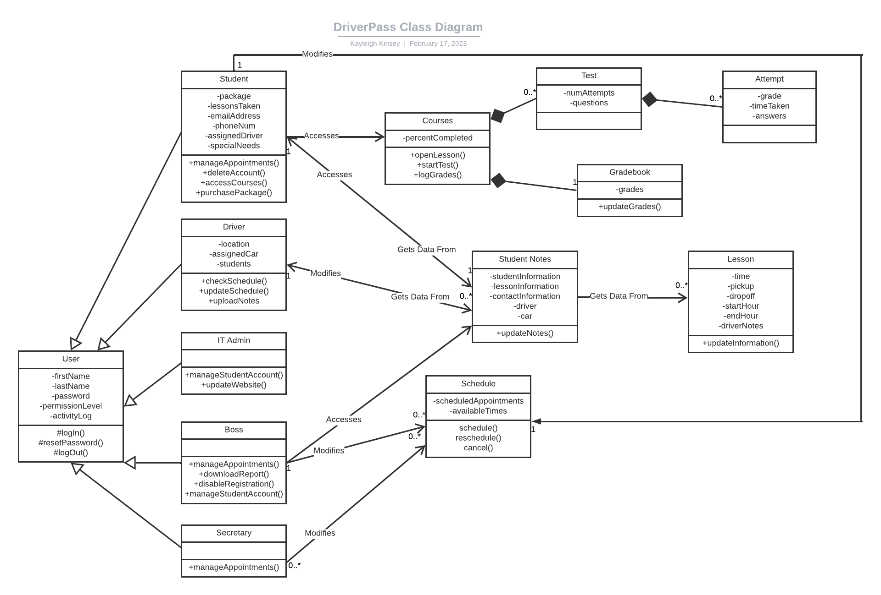

## Technical Requirements

**Hardware:**

- A computer

- An internet connection

- Servers

- An input device (such as a mouse or touchscreen) so the user can interface with the system

- A phone , so the secretary can answer calls from students to set up appointments

**Software:**

- The DriverPass System Code

- The UI

- The third-party Cloud Computing Service

- A third-party Payment Management system so DriverPass doesn’t have to worry too much about billing

- A Word Processor or similar program so the boss can read downloaded reports

- A user database that contains encrypted user information

- A customer service email address or another method for students to contact staff

**Other:**

- Cars for use during in-person lessons

- Driving instructors

- A secretary to handle calls

- Site Maintenance Manager(s) to provide updates and fix errors

- Students will need a Credit Card

- The DMV, because the system will need to reference its rules and keep up to date